**Task: 1. Write queries to return the following:**

1. Display a list of all property names and their property id’s for Owner Id: 1426.

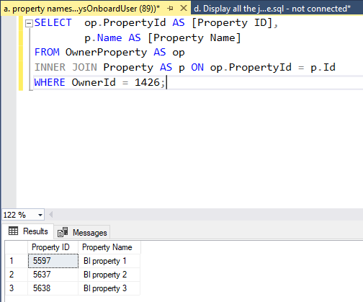

1. Display the current home value for each property in question a).

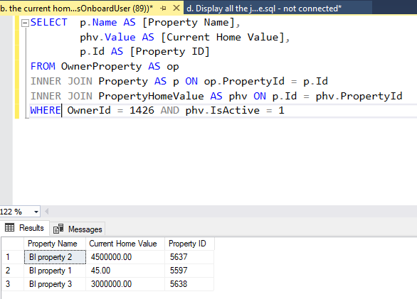

1. For each property in question a), return the following:
2. Using rental payment amount, rental payment frequency, tenant start date and tenant end date to write a query that returns the sum of all payments from start date to end date.

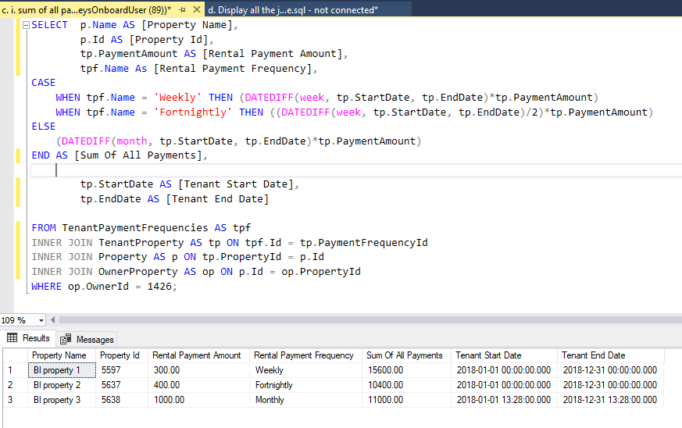

1. Display the yield.

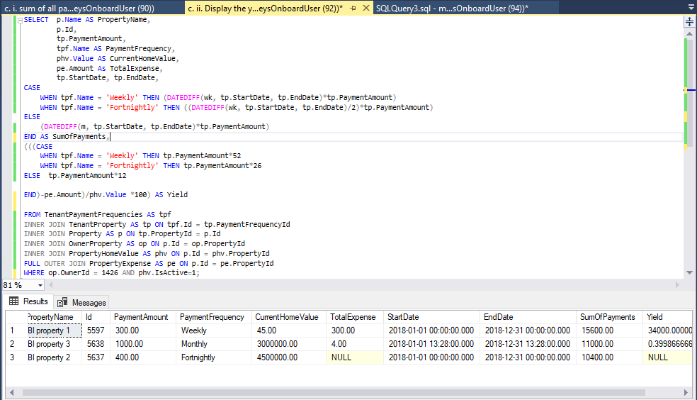

1. Display all the jobs available in the marketplace (jobs that owners have advertised for service suppliers).

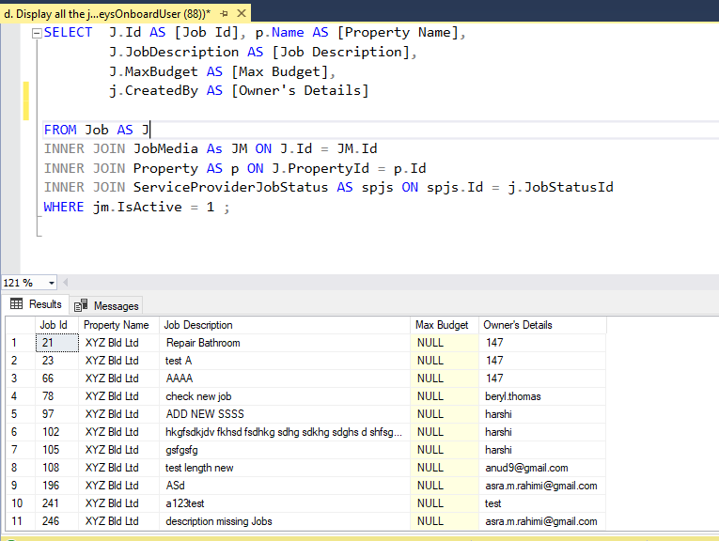

1. Display all property names, current tenants first and last names and rental payments per week/ fortnight/month for the properties in question a).

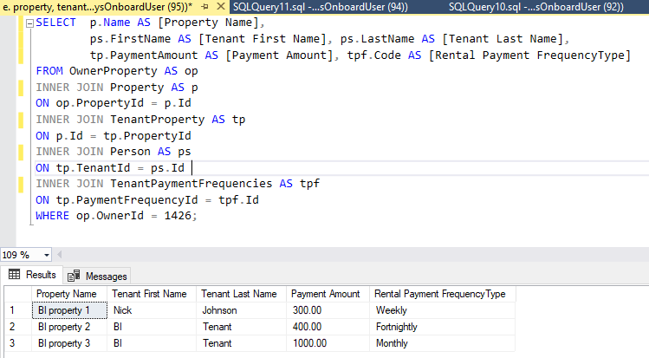

**2. Use Report Builder or Visual Studio (SSRS) to develop the following report:**

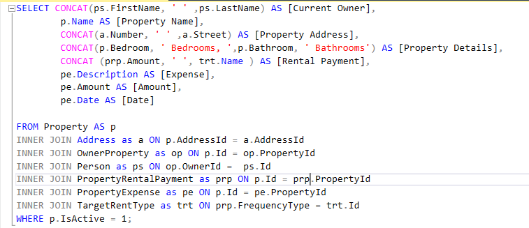

Output of Query

Query to build a report

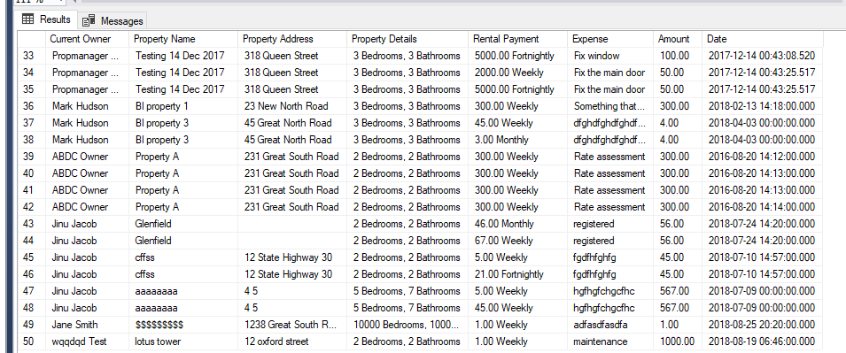

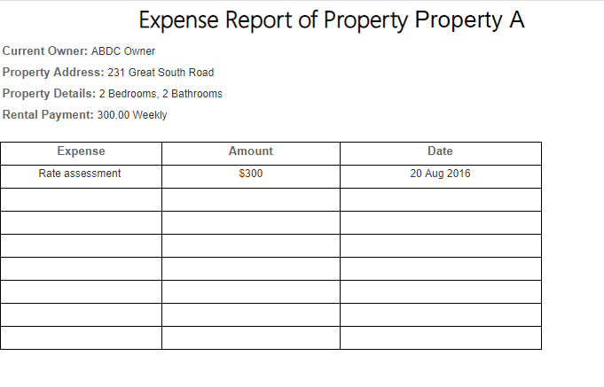

Final Report

